Lab 2: Containerization & Kubernetes Orchestration
Task 9: Record all tools documents

1. Overview
Dockerfiles, Kubernetes manifests, commands, screenshots and observations for every experiment in this lab.

2. Dockerfile (app)
# Layer 1: base image
FROM python:3.12-slim

# Layer 2: metadata / working directory
WORKDIR /app

# Layer 3: dependency manifest copied first so pip install is cached
# independently of application code changes
COPY requirements.txt .

# Layer 4: install dependencies
RUN pip install --no-cache-dir -r requirements.txt

# Layer 5: copy application source
COPY app.py .

# Layer 6: create data directory used for storage demo
RUN mkdir -p /data

# Metadata: document the port the app listens on
EXPOSE 5000

# Layer 7: default command to run the container
CMD ["python", "app.py"]

3. Docker Compose file
services:
web:
build: ./web
image: lab2-compose-web:1.0
container_name: lab2-compose-web
ports:
- "5001:5000"
environment:
- REDIS_HOST=redis
depends_on:
- redis

redis:
image: redis:7-alpine
container_name: lab2-compose-redis
expose:
- "6379"

4. Kubernetes manifests

deployment.yaml
apiVersion: apps/v1
kind: Deployment
metadata:
name: lab2-app
spec:
replicas: 2
selector:
matchLabels:
app: lab2-app
strategy:
type: RollingUpdate
rollingUpdate:
maxUnavailable: 1
maxSurge: 1
template:
metadata:
labels:
app: lab2-app
spec:
containers:
- name: web
image: lab2-python-app:1.0
imagePullPolicy: Never
ports:
- containerPort: 5000
readinessProbe:
httpGet:
path: /health
port: 5000

service.yaml
apiVersion: v1
kind: Service
metadata:
name: lab2-service
spec:
type: NodePort
selector:
app: lab2-app
ports:
- port: 80
targetPort: 5000
nodePort: 30080

5. Pipeline files

Jenkinsfile
pipeline {
agent any
stages {
stage('Build Image') { steps { bat 'docker build -t lab2-python-app:%BUILD_NUMBER% app' } }
stage('Load to Minikube') { steps { bat 'minikube image load lab2-python-app:%BUILD_NUMBER%' } }
stage('Apply Manifests') { steps { bat 'kubectl apply -f k8s/' } }
stage('Deploy New Image') { steps { bat 'kubectl set image deployment/lab2-app web=lab2-python-app:%BUILD_NUMBER%' } }
stage('Verify') { steps { bat 'kubectl rollout status deployment/lab2-app' } }
}
}

6. Commands used

Docker
docker build -t lab2-python-app:1.0 app
docker run -d --name lab2-app -p 5000:5000 lab2-python-app:1.0
docker ps / stop / start / rm
docker history lab2-python-app:1.0
docker tag / docker push localhost:5050/lab2-python-app:1.0
docker compose up -d --build / ps / down
docker volume create lab2-vol
docker run -v lab2-vol:/data ...
docker network create lab2-net
docker exec lab2-net-client curl http://lab2-net-app:5000/

Kubernetes
minikube start --driver=docker
minikube image load lab2-python-app:1.0
kubectl apply -f k8s/
kubectl get pods -o wide
kubectl set image deployment/lab2-app web=lab2-python-app:2.0
kubectl rollout status / history / undo deployment/lab2-app
kubectl scale deployment/lab2-app --replicas=5
powershell -File cicd.ps1 -Build 3

7. Screenshots and observations

Docker image build and run (Task 4)
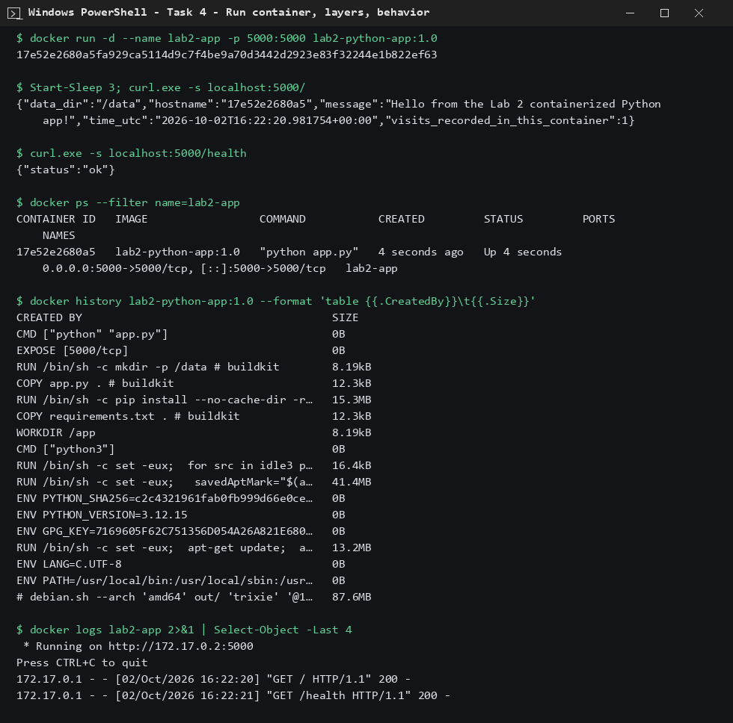
Container running and image layers
Observation: each Dockerfile instruction is one layer; the container serves / and /health.

Container management and Compose (Task 5)
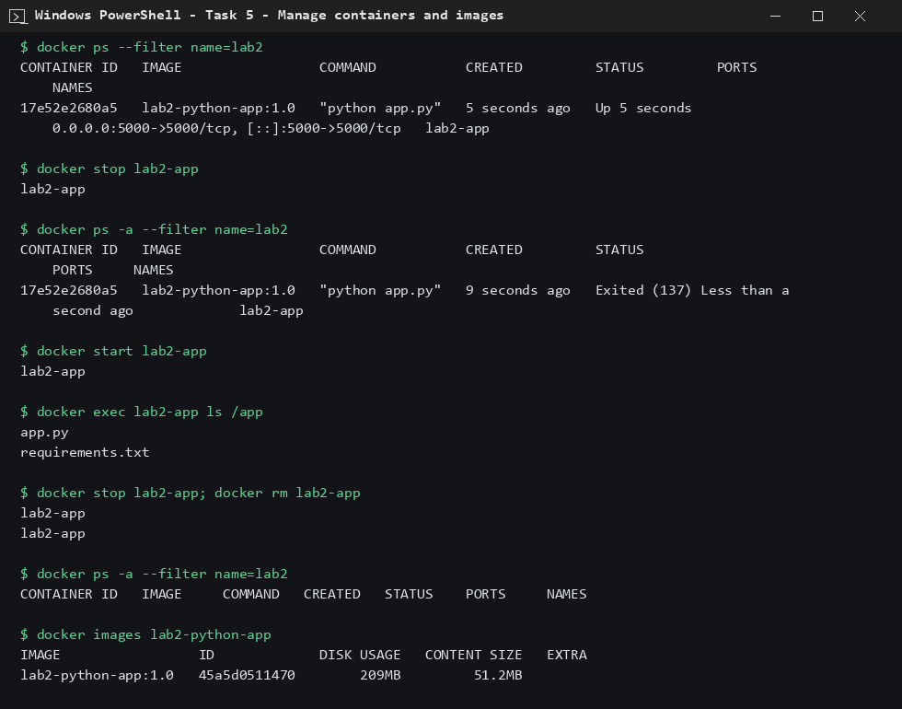
Container lifecycle
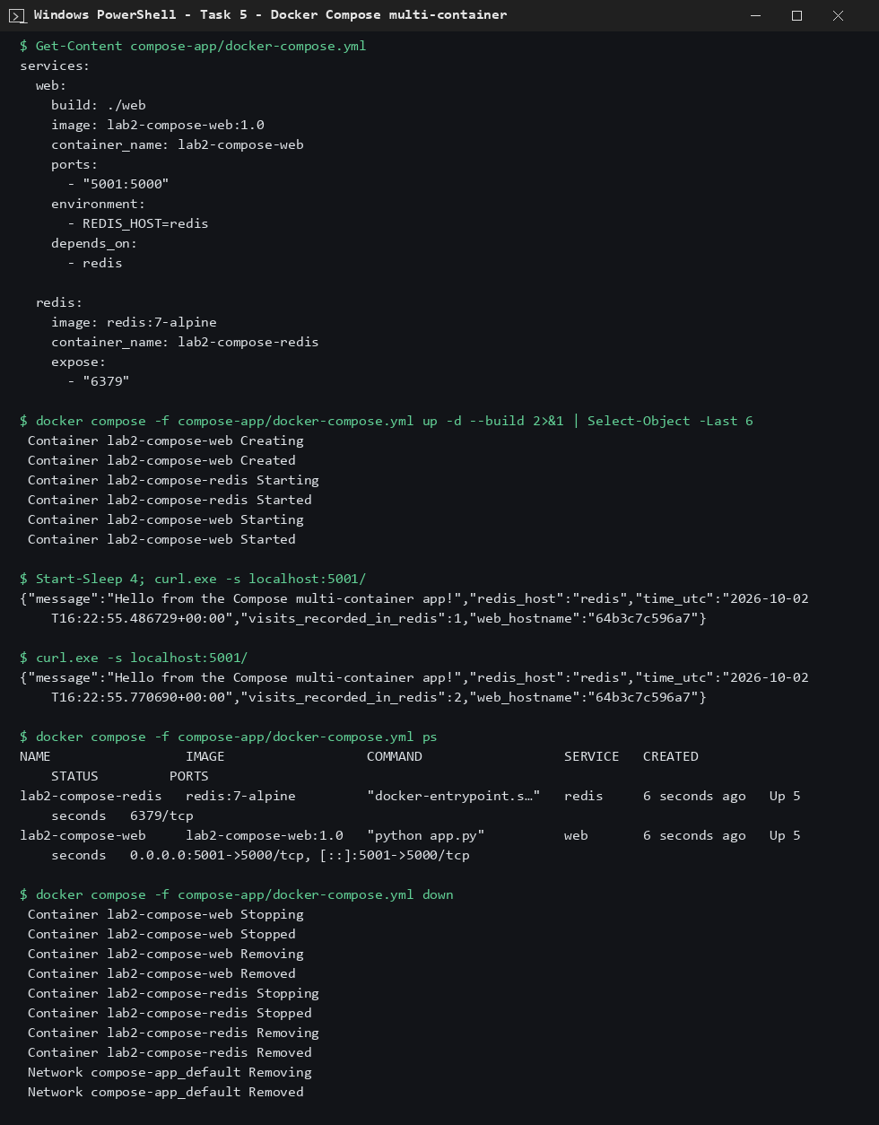
Compose with redis
Observation: Compose starts both services together; the redis counter increases per request.

Storage (Task 6)
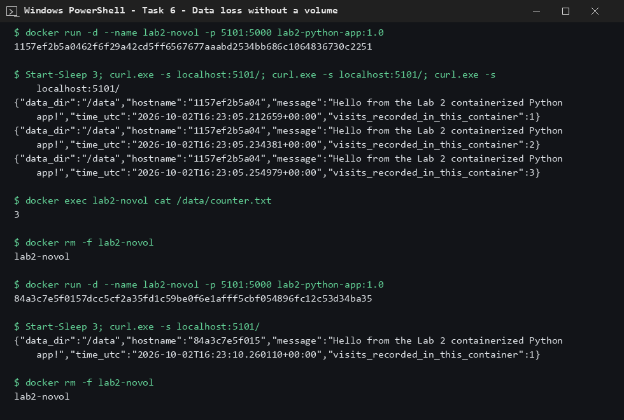
Data loss without volume
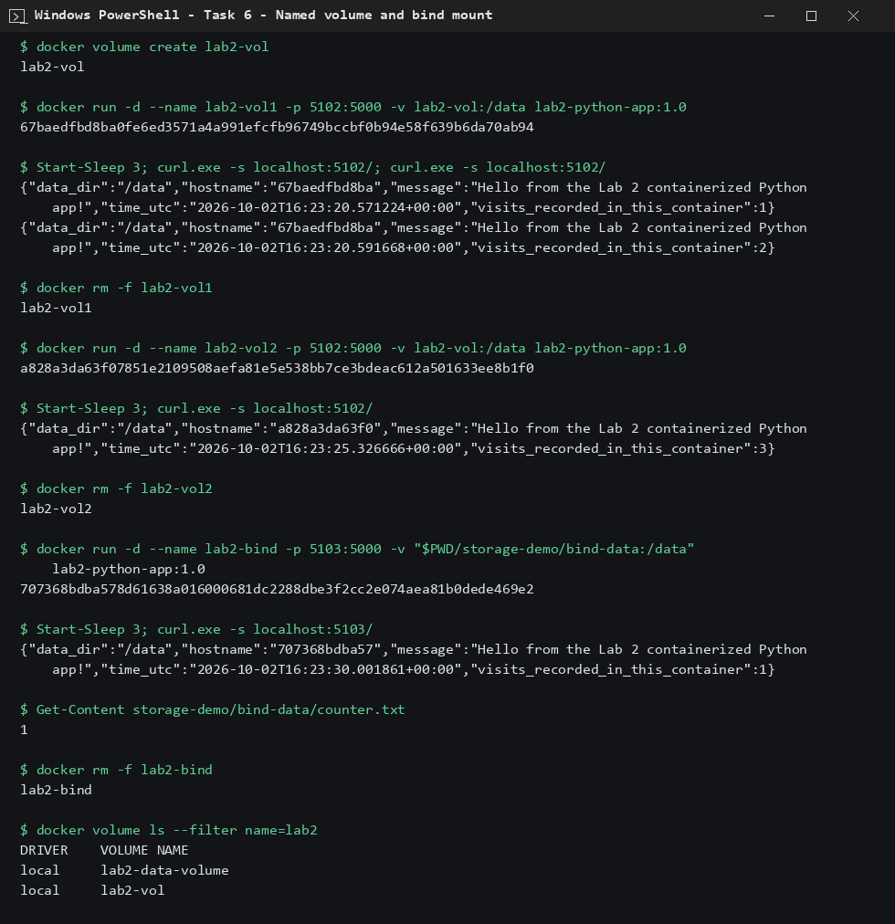
Volume and bind mount
Observation: only volumes and bind mounts keep data after the container is removed.

Network (Task 7)
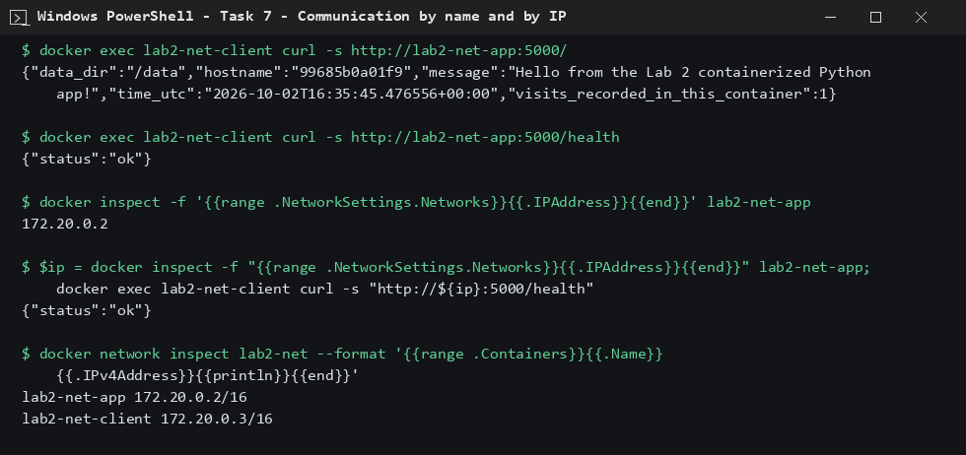
Name and IP communication
Observation: custom bridge networks provide DNS by container name.

Kubernetes (Tasks 1 and 2)
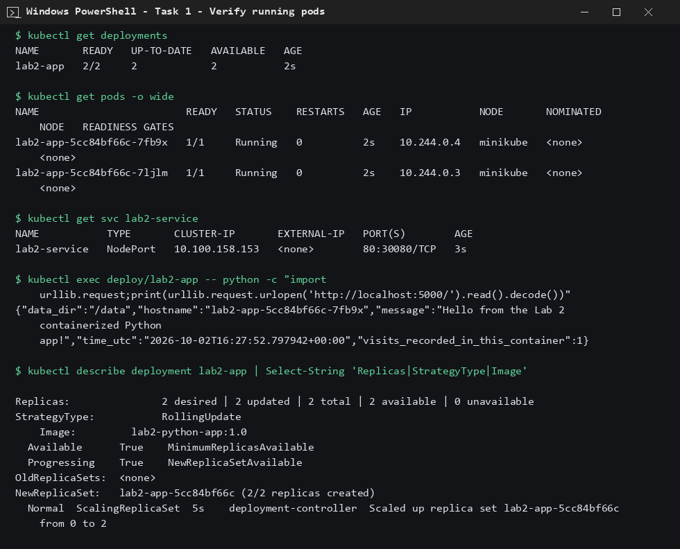
Pods and service
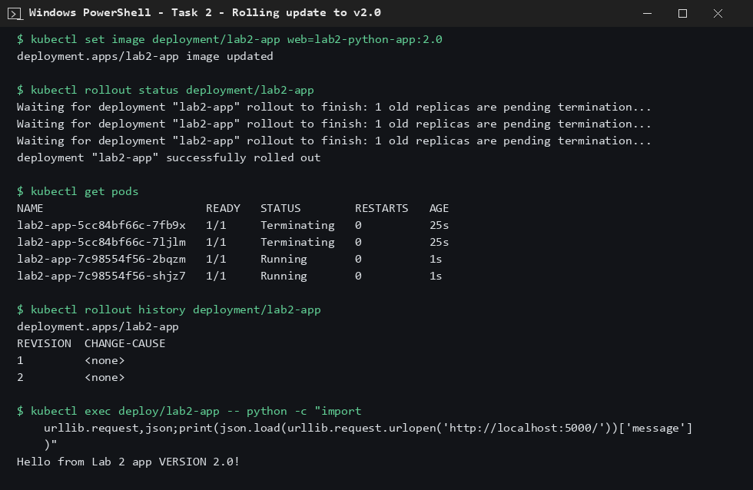
Rolling update
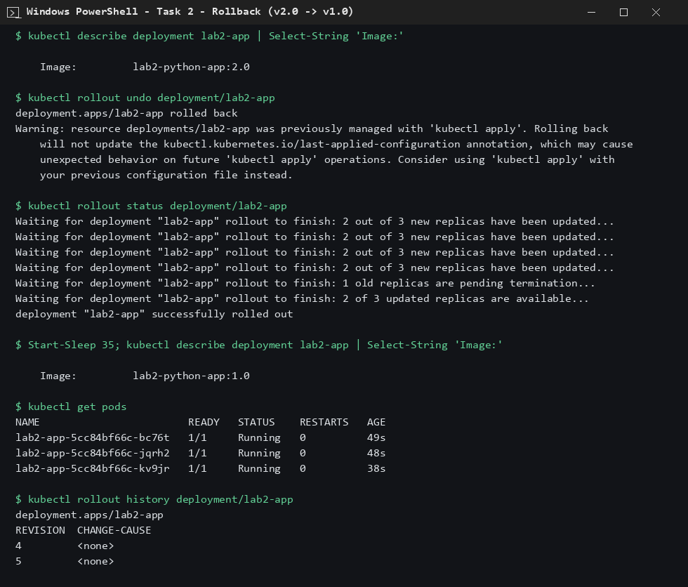
Rollback
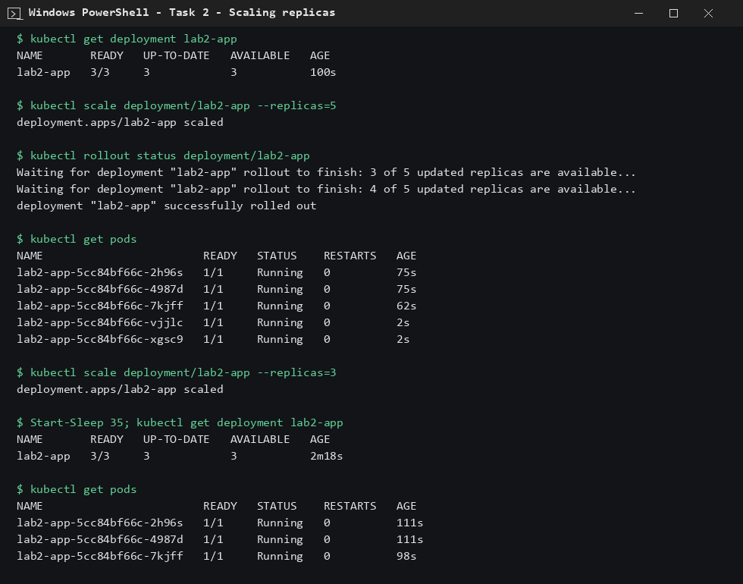
Scaling
Observation: rolling update, rollback and scaling all completed successfully.

Continuous deployment (Task 8)
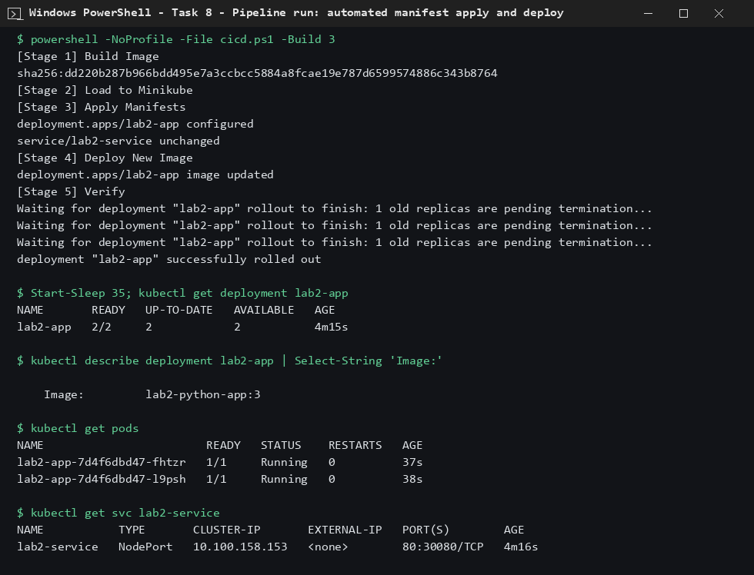
Pipeline run
Observation: one pipeline run builds, applies manifests and rolls out the new image.

